Spring Retrospective
May 22, 2024
- What technical information did you learn?
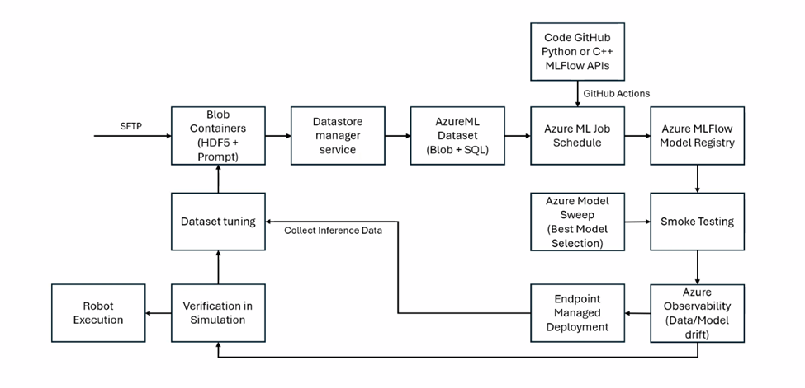This term I learned a lot about how MLFlow operates as a part of the whole architecture, and to the complete pipeline flow of the whole ecosystem. I learned about every small part that we did contributing to the bigger picture that is shown above to support training, data engineering, and deployment. That said, there are still many more things to be done to complete the cycle. We have parts of the following completed but have yet to be integrated into a full-fledged pipeline shown above: Dataset, GitHub code, MLFlow APIs, MLFlow Model Registry, and Model Sweep.
- What non-technical information did you learn?
I tend to work on urgent things rather than splitting time equally which lowers the progress of this project. Also when I foresee likely scheduling clashes that would happen in a few weeks, I failed to let the team know and I’d forget about it until the week when urgent scheduling takes place.
- What have you learned about project work?
How my expertise in certain areas could be of help to a group that is working on a separate section of the project. The fact that everything that might seem disjoint is always connected in some way. It is often easier to talk about small parts and have people working on them than to overwhelm them with the bigger picture, which leads to inefficient commitment due to a lack of specificity.

- What have you learned about project management?
Being proactive is very important as it is often a lack of proactiveness that halts the team and stalls progress. When there is no one being proactive and checking in on others, the progress seems to slow down as everyone has other tasks they are busy with, and certain tasks are often slipped out of our minds.

- What have you learned about working in teams?
Finding a common timeslot within three days can be quite challenging due to the various commitments and lifestyles of each team member. Often, someone has to adjust their plans to accommodate the group's schedule, especially when team members have different working hours. As students, we frequently face this issue because of our varying schedules and durations of availability, making it difficult to coordinate meetings. This challenge is likely to increase as teams are living in different time zones with flexible working hours, a trend that is becoming more common as jobs shift towards more flexible arrangements.

- If you could do it all over, what would you do differently?
I would set aside a certain amount of time every day or every other day to work on this as small little progress goes a long way. When I get caught up in assignments, I would often forget about capstone and proceed to meet deadlines on canvas. By setting aside some time every week, I could better keep track of my progress.

